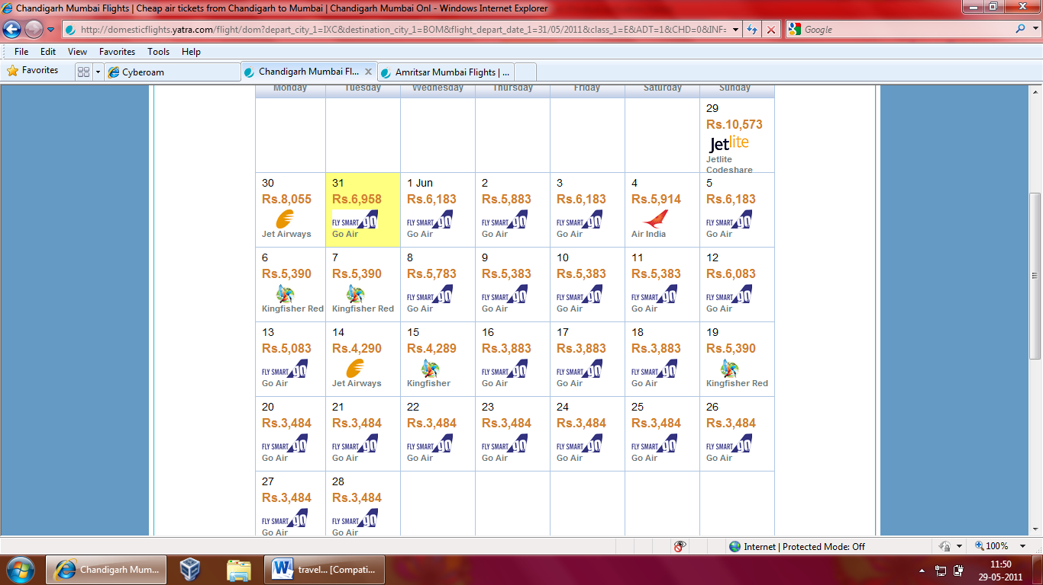

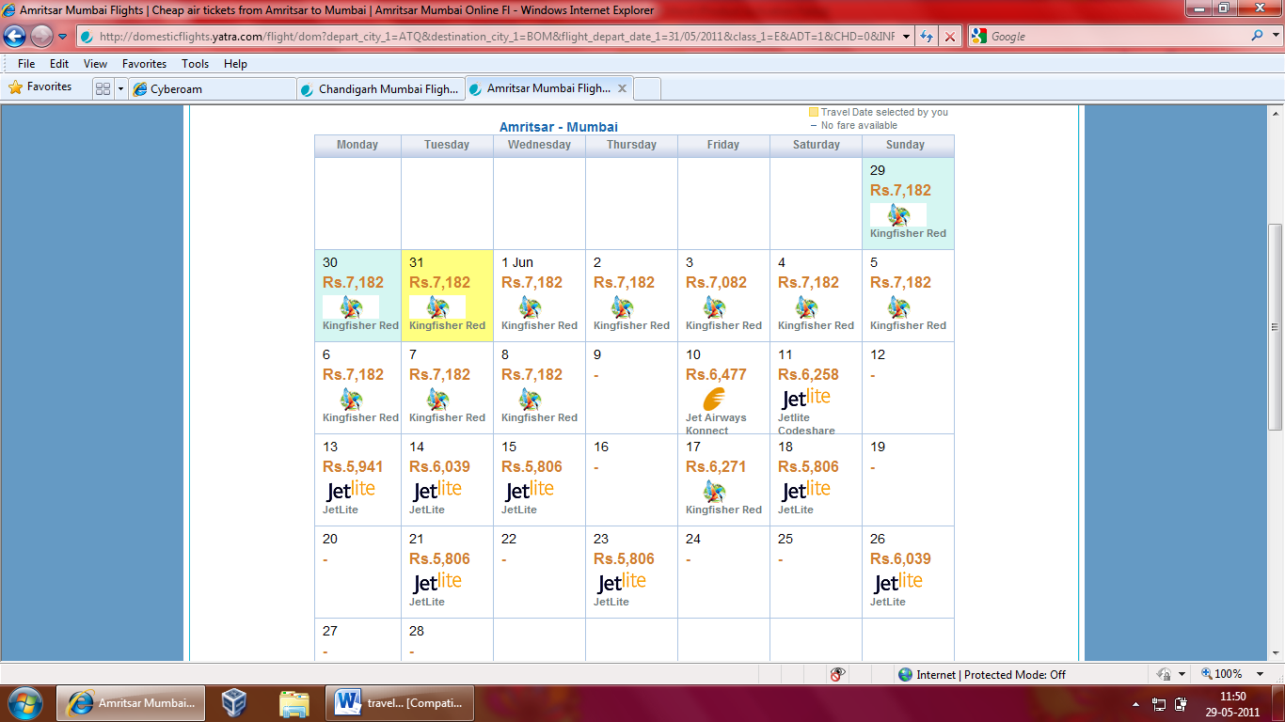

|  |  |  |  |  |  |  |  |  |  |  |  |  |  |  |  |  |  |  |  |  |  |  |  |  |  |  |  |  |  |  |  |  |  |  |  |  |  |  |  |  |  |  |  |  |  |  |  |  |  |  |  |  |  |  |  |  |  |  |  |  |  |  |  |  |  |  |  |  |  |  |  |  |  |  |  |  |  |  |  |  |  |  |  |  |  |  |  |  |  |  |  |  |  |  |  |  |  |  |  |  |  |  |
| --- | --- | --- | --- | --- | --- | --- | --- | --- | --- | --- | --- | --- | --- | --- | --- | --- | --- | --- | --- | --- | --- | --- | --- | --- | --- | --- | --- | --- | --- | --- | --- | --- | --- | --- | --- | --- | --- | --- | --- | --- | --- | --- | --- | --- | --- | --- | --- | --- | --- | --- | --- | --- | --- | --- | --- | --- | --- | --- | --- | --- | --- | --- | --- | --- | --- | --- | --- | --- | --- | --- | --- | --- | --- | --- | --- | --- | --- | --- | --- | --- | --- | --- | --- | --- | --- | --- | --- | --- | --- | --- | --- | --- | --- | --- | --- | --- | --- | --- | --- | --- | --- | --- |
| **Go Air**  G8-145  **11:40**, Wed 01 Jun' 11  Chandigarh  Chandigarh A F Base  **13:55**, Wed 01 Jun' 11  Mumbai  CSI Airport  2hr 15min  Non Stop  Paid Meal | Baggage: 20.0kgs | Refundable | [Fare Rules](http://domesticflights.yatra.com/flight/dom?depart_city_1=IXC&destination_city_1=BOM&flight_depart_date_1=31/05/2011&class_1=E&ADT=1&CHD=0&INF=0&type=O&siteLanguage=en_IN&multiplyFactor=1&eVar45=DIRECT:) | [Earn 52](http://domesticflights.yatra.com/flight/dom?depart_city_1=IXC&destination_city_1=BOM&flight_depart_date_1=31/05/2011&class_1=E&ADT=1&CHD=0&INF=0&type=O&siteLanguage=en_IN&multiplyFactor=1&eVar45=DIRECT:) | **Rs.6,183**  **Fare Summary**   |  | | --- | | **Fare Summary** | | | **Passengers** |  | **Base Fare** | |  | **Taxes & Fees** | |  | **Per Passenger** | | |  | **Total Fare** | | | --- | --- | --- | --- | --- | --- | --- | --- | --- | --- | --- | --- | --- | --- | |  | | | | | | | | | | | | | | | | | | Adult |  | Rs. | 2,600 |  | Rs. | 3,583 |  | Rs. | 6,183 | x 1 |  | Rs. | 6,183 |  |  |  | |  | | | | | | | | | | | | | | | | | |  |  |  |  |  |  |  |  | **Total Price** | | | | **Rs.** | **6,183** |  |  |  | | *Total Fare displayed above has been rounded off and may thus show a slight difference. | | | | | | | | | | | | | | | | | | |